*Samyak Jain*

*21058*

*Section A*

*April 2024*

*BCT Data Analysis Research Project on,*

**Cross National Study on Life Expectancy and its Determinants.**

**ABSTRACT**

This research paper investigates the multifaceted determinants of life expectancy across countries by analyzing various health, GDP, and education factors and doing a cross national comparison. Utilizing a comprehensive dataset encompassing these variables for numerous nations, we explore the intricate relationships between socioeconomic indicators and life expectancy. Through rigorous statistical analysis and data interpretation, we derive significant insights into the factors influencing life expectancy and their relative importance. Our findings shed light on the complex interplay between health outcomes, economic development, and educational attainment, offering valuable implications for policymakers and public health practitioners striving to improve population health and longevity.

**INTRODUCTION**

Life expectancy stands as a fundamental metric reflecting the overall health and well-being of populations worldwide. It serves not only as a barometer of societal progress but also as a crucial indicator guiding public health interventions and policy decisions. Understanding the determinants of life expectancy is imperative for addressing disparities in health outcomes and fostering sustainable development goals. This research endeavors to unravel the intricate web of factors shaping life expectancy, delving into the realms of healthcare access, economic prosperity, and educational attainment.

Drawing on a comprehensive dataset spanning various health indicators, GDP metrics, and educational parameters for a diverse array of countries, we embark on a systematic analysis to elucidate the multifaceted influences on life expectancy. By employing advanced statistical techniques and data visualization tools, we aim to discern patterns, correlations, and causal relationships among the variables under scrutiny. Our investigation seeks to move beyond mere descriptive analyses to uncover deeper insights into the underlying mechanisms driving differences in life expectancy across nations.

The significance of this research lies in its potential to inform evidence-based policymaking aimed at enhancing population health outcomes and promoting longevity globally. By identifying the key determinants of life expectancy and their relative importance, we aspire to contribute valuable knowledge to the fields of public health, economics, and education. Through our empirical findings and analytical rigor, we endeavor to offer actionable recommendations for policymakers, healthcare professionals, and educators striving to foster healthier and more equitable societies.

**LITERATURE REVIEW**

Literature review was conducted on three studies ([5][6][7]) to determine the various factors which affect life expectancy.

According to [5], (1) health care expenditures, (2) health financing policies, (3) elements of medical care, (4) health habits and population health, (5) social determinants, (6) social spending, and (7) other external factors are the factors when it comes to life expectancy.

Financial income and literacy rates are shown to be indicators of life expectancy [6].

According to Baker and Fugh-Berman (2009), infant mortality is the single most important determinant of life expectancy. [7]

**METHODS AND DATA**

Secondary data has been collected through various online sources as mentioned in references. [1][2][3][4]

Microsoft Excel has been used for the analysis.

A WHO dataset available on Kaggle has been analyzed, all variables were checked if they were suitable for the regression first, then put through regression from which conclusions are drawn.

The important explanations for different columns are as follows:

Adult Mortality Rates: Adult Mortality Rates of both sexes (probability of dying between 15 and 60 years per 1000 population)

Infant deaths: Number of Infant Deaths per 1000 population

Alcohol: Alcohol, recorded per capita (15+) consumption (in liters of pure alcohol)

Percentage expenditure: Expenditure on health as a percentage of Gross Domestic Product per capita (%)

Hepatitis B: Hepatitis B (HepB) immunization coverage among 1-year-olds (%)

Measles: Measles - number of reported cases per 1000 population

Under-five deaths: Number of under-five deaths per 1000 population

Polio: Polio (Pol3) immunization coverage among 1-year-olds (%)

total expenditure: General government expenditure on health as a percentage of total government expenditure (%)

diphtheria: Diphtheria tetanus toxoid and pertussis (DTP3) immunization coverage among 1-year-olds (%)

HIV/AIDS: Deaths per 1 000 live births HIV/AIDS (0-4 years)

Schooling: Number of years of Schooling(years)

**DISCUSSION**

The primary objective of the study was to determine the most influential variables of life expectancy from the many which were provided in the dataset.

Also, to compare the developed nations with the developing nations on the basis of their overall quality of life, life expectancy and its determinants.

Finally, to determine an equation through which life expectancy can be predicted.

**FINDINGS AND IMPLICATIONS**

The dataset after cleaning had 143 countries, out of which 112 (78%) are developing countries and the rest 32 (22%) are developed countries.

(Clearer visualizations in the visualization section.)

Through correlation tables, the most significant variables which define variation in life expectancy were found out to be: Adult Mortality, Alcohol, GDP per capita, Schooling, HIV/AIDS, Polio, and Total expenditure.

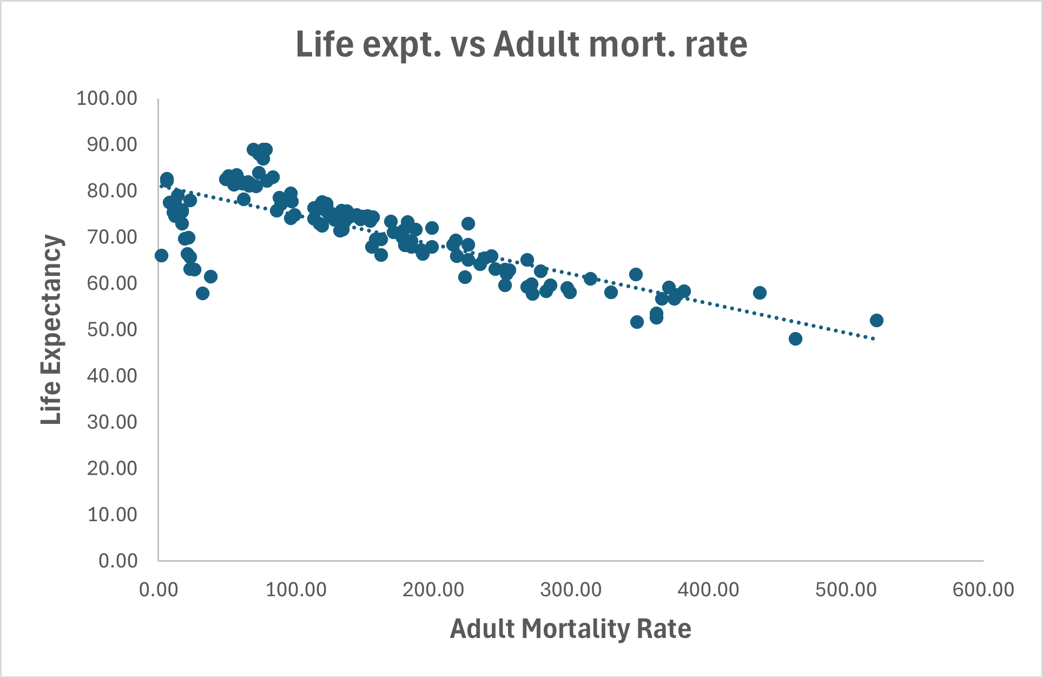The multiple regression using these variables was statistically significant as their R2 was 0.84 or 84% which means about 84% of the variation in life expectancy is explained by our selected variables.

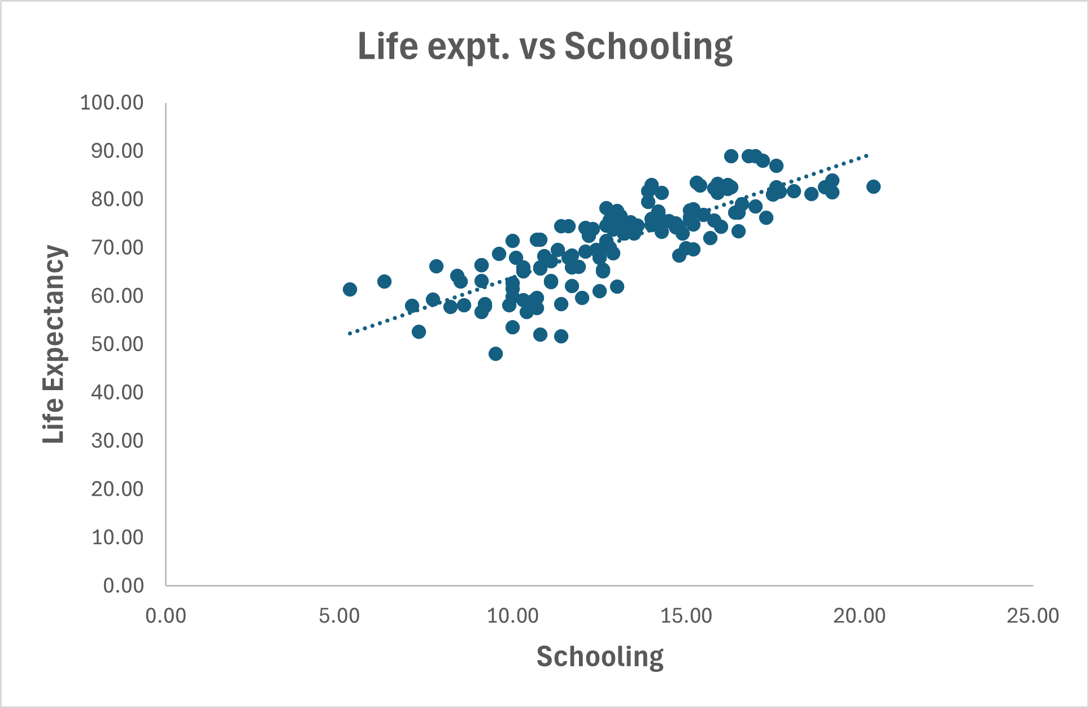These are the various coefficients of the variables studied. The coefficients indicate how strongly they change the dependent variable.

Further looking into the multiple regression, it was found out that p value of only adult mortality rate, schooling and HIV/AIDS were below the significance level of 5% of 0.05.

Looking on the individual relationships, the correlation between adult mortality rate and life expectancy is -0.78, which denotes a strong negative correlation between the two.

That between schooling and life expectancy is 0.82, denoting a positive relation between how educated one is and how long they live.

And, between HIV/AIDS and life expectancy is -0.62, which shows a decently strong inverse relationship.

Finally, we found out the difference in developed countries and developing countries in terms of these factors and life expectancy.

First, it was found out that average adult mortality of developing countries is 2.3 times higher than that of developed countries,

People of developed countries are 1.4 times more educated than those of developing countries,

A death due to HIV/AIDS among infants is 9 times more likely in a developing country when compared to a developed country.

Finally, the average life expectancy of developing countries (68.7) was found out to be even lower than the lowest life expectancy of the developed countries (73.4). When comparing the averages directly, a person from the developed countries is expected to live 1.2 times longer than a person from the developing countries.

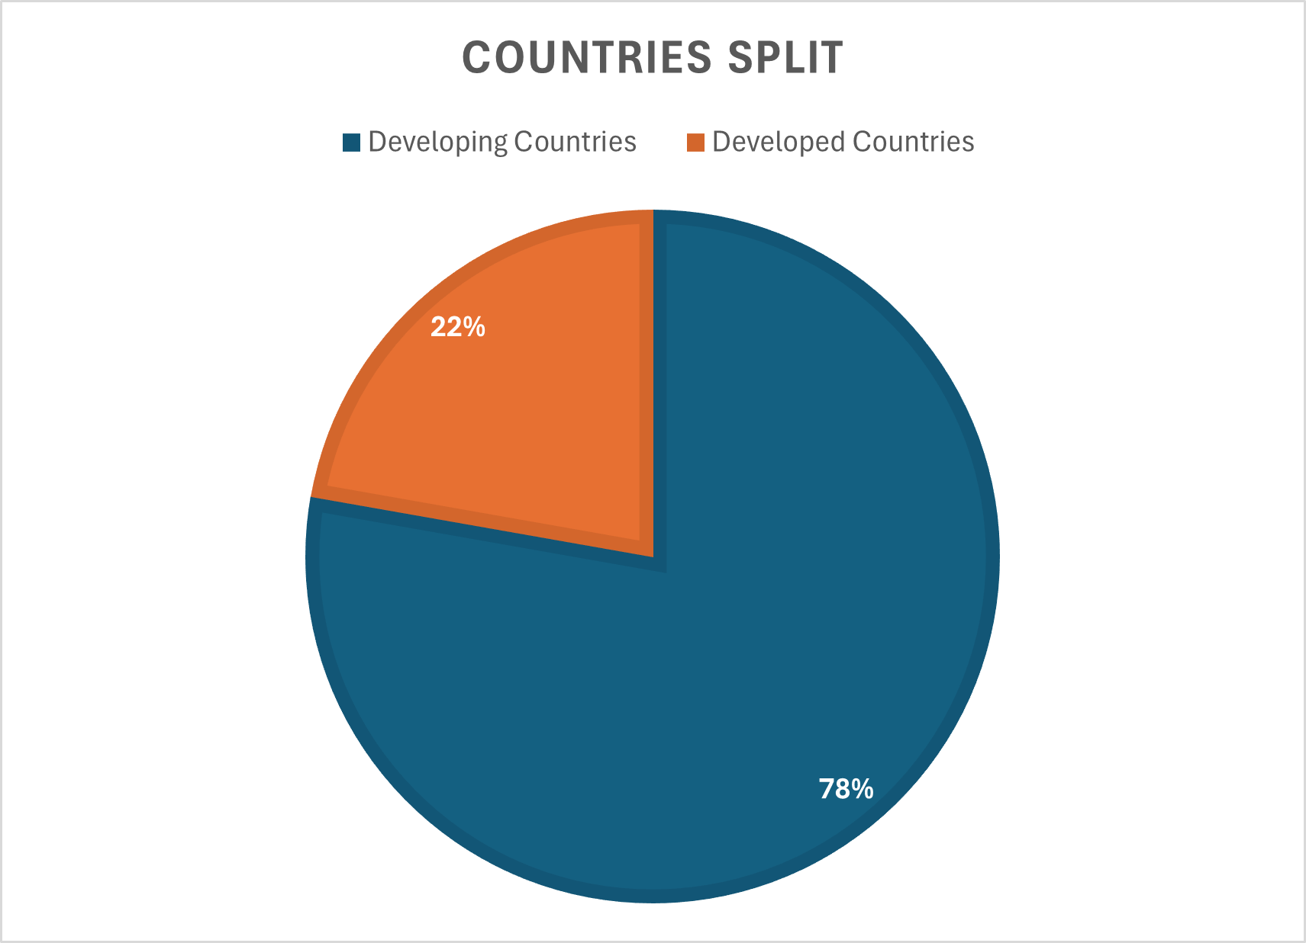**VISUALIZATION**

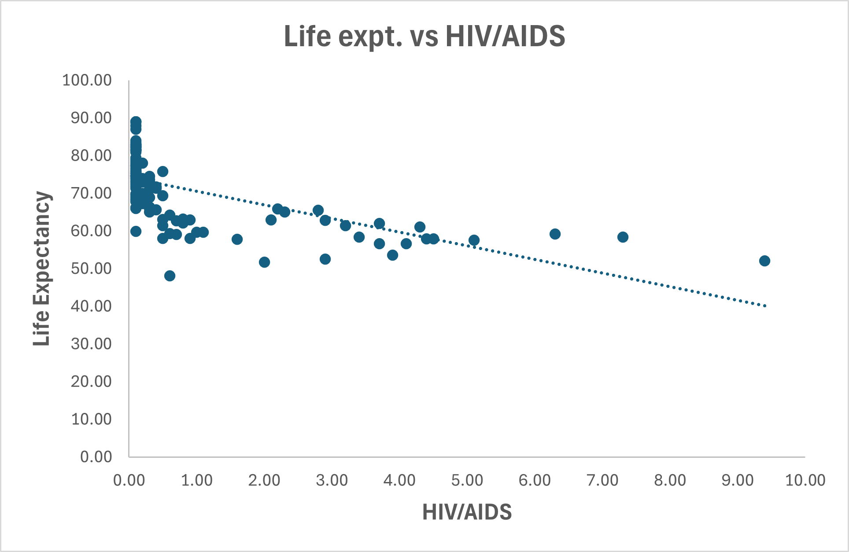

**CONCLUSION**

It is to be noted that there are many factors that could not be accounted for while doing this research, so with what was available, these are the conclusions of this study. This study suggests that the most influential factors of life expectancy are number of years of schooling and adult mortality rate. Also, deaths due to HIV/AIDS under 4 is another important factor. An inverse relationship of adult mortality and HIV/AIDS has been noticed with life expectancy and a positive one of schooling with life expectancy.

The overall quality of life, judging from the comparison, of the developing countries is far behind that of developed countries. The focus of developing countries should be to work on these factors to improve the life expectancy and hence overall quality of life of their people.

**REFERENCES**

1. *Life Expectancy (WHO)* by **KUMARRAJARSHI.**

*(*[*https://www.kaggle.com/datasets/kumarajarshi/life-expectancy-who*](https://www.kaggle.com/datasets/kumarajarshi/life-expectancy-who)*)*

1. *Human Development Reports* by **UNDP.**

*(*[*https://hdr.undp.org/data-center/specific-country-data#/countries/USA*](https://hdr.undp.org/data-center/specific-country-data#/countries/USA)*)*

1. *Population change - year 2014* by **Czech Statistical Office.**

*(*[*https://www.czso.cz/csu/czso/ari/population-change-4-quarter-2014-q91zsn7atp*](https://www.czso.cz/csu/czso/ari/population-change-4-quarter-2014-q91zsn7atp)*)*

1. *World Development Indications* by **The World Bank.**

*(*[*https://datatopics.worldbank.org/world-development-indicators/*](https://datatopics.worldbank.org/world-development-indicators/)*)*

1. *Determinants of life expectancy at birth: a longitudinal study on OECD countries* by **Paolo Roffia, Alessandro Bucciol, and Sara Hashlamoun.**

*(*[*https://www.ncbi.nlm.nih.gov/pmc/articles/PMC9650666/#:~:text=From%20the%20literature%20we%20identified,(7)%20other%20external%20factors*](https://www.ncbi.nlm.nih.gov/pmc/articles/PMC9650666/#:~:text=From%20the%20literature%20we%20identified,(7)%20other%20external%20factors)*)*

1. *Factors effecting life expectency in developed and developing countries of the world (An approach to available literature)* by **Alamgir Khan, Dr. Salahuddin Khan, Manzoor Khan.**

*(*[*https://www.researchgate.net/publication/310240265_Factors_effecting_life_expectancy_in_developed_and_developing_countries_of_the_world_An_approach_to_available_literature*](https://www.researchgate.net/publication/310240265_Factors_effecting_life_expectancy_in_developed_and_developing_countries_of_the_world_An_approach_to_available_literature)*)*

1. *Do New Drugs Increase Life Expectancy? A Critique of a Manhattan Institute Paper* by **Dean Baker, PhD and Adriane Fugh-Berman, MD.**

*(*[*https://www.researchgate.net/publication/24221574_Do_New_Drugs_Increase_Life_Expectancy_A_Critique_of_a_Manhattan_Institute_Paper*](https://www.researchgate.net/publication/24221574_Do_New_Drugs_Increase_Life_Expectancy_A_Critique_of_a_Manhattan_Institute_Paper)*)*